**ARTH - Task 26** 👨🏻‍💻

**Task Description** 📄

📌 **GUI container on the Docker**

🔅 **Run any GUI software on the container**

📌 **Prerequisite:**

**- For GUI Application to run we need to have** **XServer**.

**- But container don’t have XServer so it will share the XServer from the host instance i.e. host & container will have common XServer.**

**- Firefox works as the client of XServer.**

**- We need to mount /tmp/.X11-unix** **folder of host to /tmp/.X11-unix folder of container because it contains :X0 socket.**

**- :X0 is socket, through which client contact/connect to XServer.**

**- We also need to specify environment variable named** **DISPLAY which has value same as env variable($DISPLAY) of host instance.**

⭕**Steps to be performed:**

* **Create a docker image:**

**Docker image contains firefox s/w installed, so when ever we launch container using that image firefox will be launched from container.**

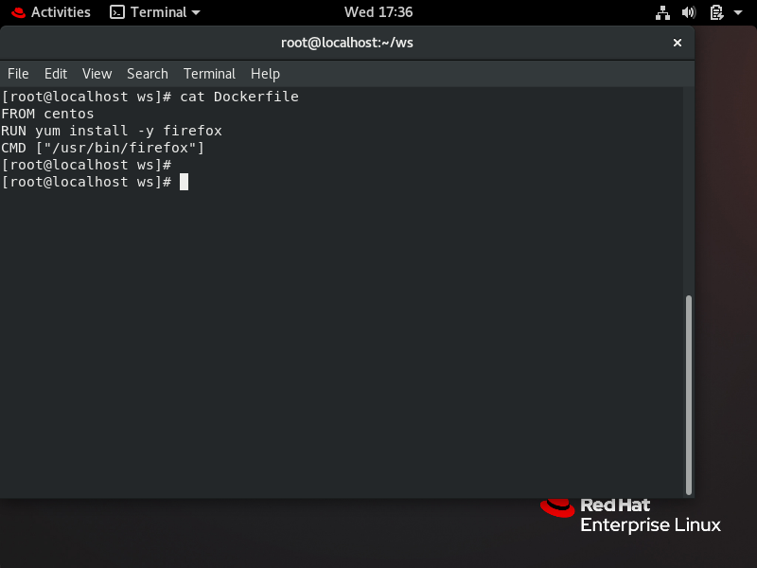

* **:X0 socket in /tmp/.X11-unix/**

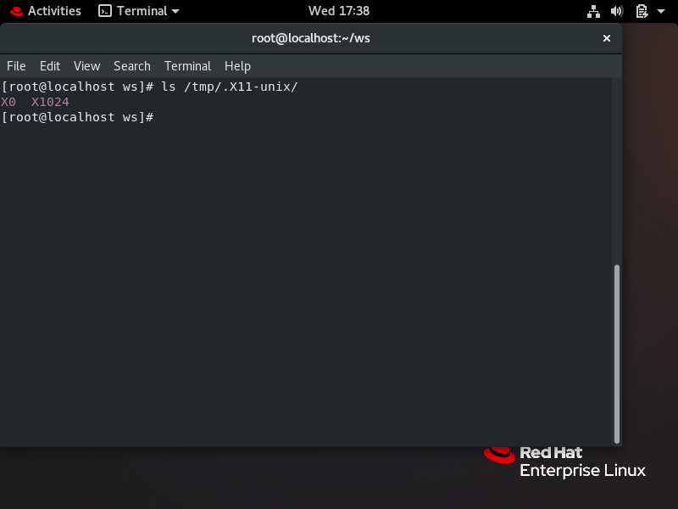

* **I created docker image named “gui”**

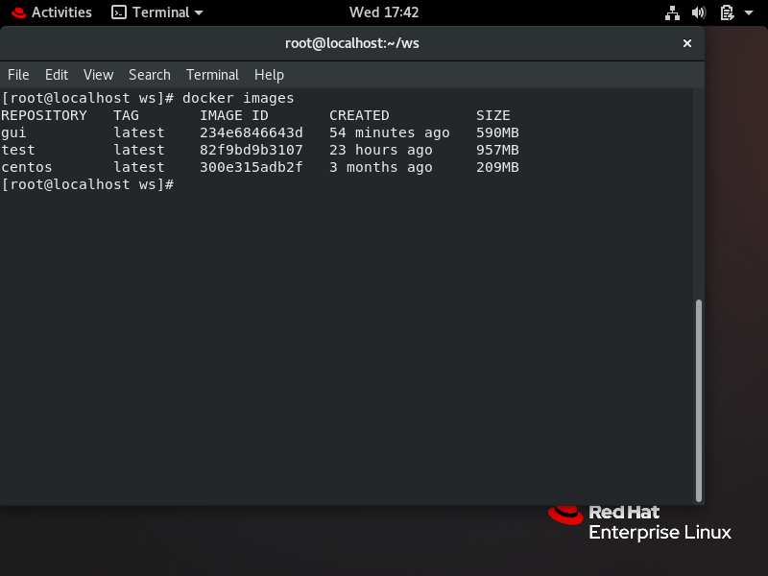

* **Then while launching container from that image we need to provide env variable “*DISPLAY*” to container.**

**It’s value would be same as value of “*DISPLAY*” variable in host instance.**

* **Also we need to mount */tmp/.X11-unix* folder of host instance to */tmp/.X11-unix* folder of container. It will provide socket(:X0) to container through which firefox s/w of container will communicate to XServer of host instance.**
* **Hence firefox from container would be launch on host instance by using XServer of host instance**

**❗ CMD:** **docker run -it -e DISPLAY=”$DISPLAY” -v /tmp/.X11-unix:/tmp/.X11-unix**

**❗ We use “-e” for specifying env variable & “-v” for mounting volume.**

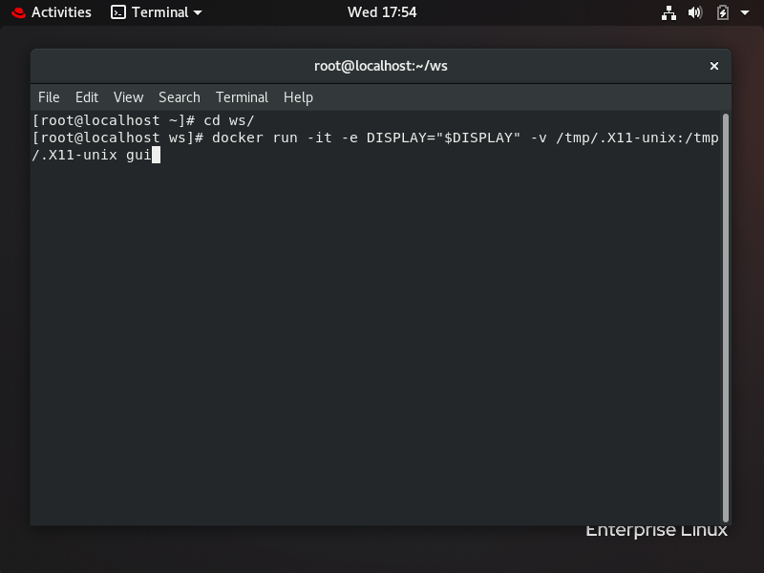

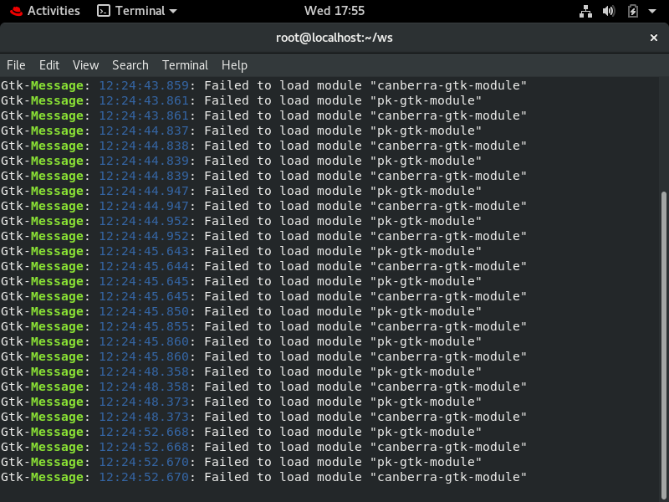

📌 **Firefox launched on host instance**

